Task 1

Label the following pieces of laboratory equipment

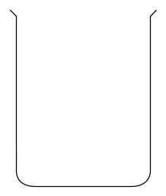 |  | 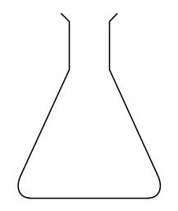 |  | 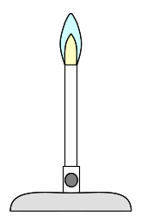
1. |  | 2. |  | 3.
 |  | 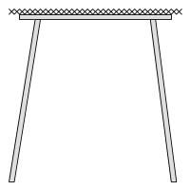 |  | 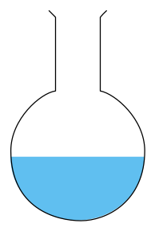
4. |  | 5. |  | 6.
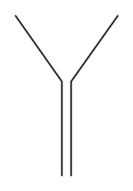 |  | 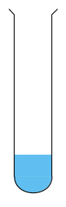
7. |  | 8. |  | 9.

Draw diagrams below for an evaporating basin and a pestle and mortar.

Task 2
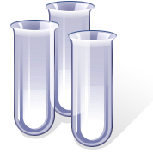
Which items of laboratory equipment would you use in the following situations?

- Heating a small quantity of a solid chemical.

- Heating a small quantity of a liquid chemical.

- Grinding lumps of rock salt into a powder.

- Filtering dirty water.

- Mixing two liquids by gently shaking.

- Heating a 250cm³ of a solution to boiling point.

- Obtaining salt from a salt solution by heating strongly.

- Measuring the boiling point of water.

- Dissolving salt in water by stirring.

- Heating a small sheet of copper metal.

Answers

Task 1

- Beaker | - Conical flask | - Bunsen burner
- Thermometer | - Tripod and gauze | - Round bottomed flask
- Filter funnel | - Boiling tube | - Test tube

Draw diagrams below for an evaporating basin and a pestle and mortar.
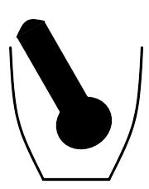



Task 2
- NB Safety glasses are needed in all of the following situations.
- Bunsen burner, test tube, test tube holder, safety mat
- Bunsen burner, boiling tube, test tube holder, safety mat
- Pestle and mortar
- Filter funnel, filter paper, beaker or conical flask to collect liquid, clamp stand to support filter funnel
- Conical flask
- Round bottomed flask or beaker
- Evaporating basin, Bunsen burner, tripod and gauze, safety mat
- Thermometer
- Beaker and stirring rod
- Bunsen burner, tongs, safety mat

